# DESIGN THINKING ACTIVITY PLAN TEMPLATE

## BASIC INFORMATION

PROJECT TITLE:

Title of the Design Thinking (DT) Project

AUTHOR(S):

Name(s) of teacher (s), designer(s), researcher(s) who created the Activity Plan

ISSUE:

Briefly Describe the **problem** or the **topic** that this DT project seeks to solve in 1-2 sentences.

*E.g. Metal mining for jewellery production purposes has a hugely detrimental impact on the planet. In times critical for environmental sustainability, it is important for the industry to develop more sustainable methods for jewellery production.*

FINAL STUDENT PRODUCTION:

What is the expected final artifact that will be produced by the students using emerging technologies throughout the DT project?

*e.g.1 a 3D model of a jewel*

*e.g.2 a GIS simulation game for sustainable transportation in the city*

ΤECHNOLOGIES TO BE USED:

Select the ExtenDT2 technologies that will be used by students during the DT Project

MaLT2    ChoiCo  SorBET  VRobotics  NQuire

## FOCUS, SET UP & REQUIREMENTS OF THE ACTIVITY

### 2.1 LEARNING OUTCOMES

You can find the Learning objectives Verbs [here](https://www.utica.edu/academic/Assessment/new/Blooms%20Taxonomy%20-%20Best.pdf)

| Domain Related | |
| --- | --- |
| *e.g. 1 Mathematics* | *e.g.1* ***Use*** *the mathematical properties of the 3D shapes to design the digital jewel model (Mathematics)* |
| *e.g. 2 Chemistry* | *e.g. 2* ***Decide*** *on the material for printing the 3D model (Chemistry)* |
| Design Thinking & innovation with Emerging Technologies Related | |
| *e.g. 3 Prototyping* | *e.g. 3* ***Create*** *different prototypes of 3D models (MaLT2 & 3D printing)* |
| *e.g. 4 Analysis* | *e.g. 4* ***Interpret*** *questionnaires answers to design criteria for the model they create.* |
| *e.g 5 Reflecting & Feedback* | *e.g. 5* ***Relate*** *the feedback from their peers to iterations they did to the prototype* |
| 21st century Skills Related | |
| *e.g 6* Communication | e.g. 6 **Explain** their ideas to others. |
|  | *e.g. 7* ***Discuss*** *different solutions to the issue at hand.* |
| *e.g 7 Presentation* | *e.g.8* ***Present*** *their final artifact by demonstration* |

### 2.2 PARTICIPANTS & CONTEXT

#### STUDENTS

| Age | *10-11 years old* |
| --- | --- |
| Prior knowledge | *basic knowledge of programming concepts with Logo* |
| Nationality, gender, cultural background | *1 pupil is from Albania and 21 from Greece, 15 boys & 7 girls* |
| Language | *Greek* |
| Special needs and abilities | - |

#### TIME

ACTIVITY DURATION: *e.g. 8 hours divided into 4 times* ***(min 8 hours - 2 sessions)***

IMPLEMENTATION DURATION: *e.g. 4 weeks*

SCHEDULE*: e.g. 2 hours/week*

#### SPACE

Specify where the activity will take place

ACTIVITY TYPE: In-person    At distance  Mixed

PHYSICAL SPACE: *e.g. computer laboratory, classroom*

VIRTUAL SPACE: *e.g. moodle platform, Miro Platform MS-TEAMS platform, E-class*

### 2.3 SOCIAL ORCHESTRATION

#### PEOPLE INVOLVED

No of STUDENTS: No of GROUPS : No of TUTORS: No of ASSISTANTS:

#### STUDENT GROUPING & INTERACTIONS

| Grouping Criteria | *e.g. mixed school performance, student preferences* |
| --- | --- |
| Organisation | *e.g. 3 students per group using 1 computer per group* ***(min 2, max 5 students/group)*** |
| Roles in the group | *e.g. pre-defined roles; emergent roles; role exchange in the group (in case the roles are predefined by the teacher, provide more details about what each role is expected to be responsible for)* |
| Tutor(s) role(s) | *e.g. intervene; monitor; facilitate; guide; observe* |

### TEACHING RESOURCES

| Digital resources | *e.g. MaLT2 microworld with basic 2D & 3D models created by the teacher (a pyramid, a cube, a circle)* |
| --- | --- |
| Physical resources | *e.g. a 3D printed model, workbook* |

## IMPLEMENTATION - DESIGN THINKING ACTIVITY FLOW

This section describes how the teaching and learning process is expected to evolve through the 5 phases of the Design Thinking Methodology: 1. Empathise & Understand, 2. Define & Ideate, 3. Rapid prototyping & Iteration, 4. Sharing & Feedback, 5. Respond & Deliver. The described activities should support the objectives stated and make use of the technologies, supporting material, and teaching and learning processes mentioned earlier in the activity plan.

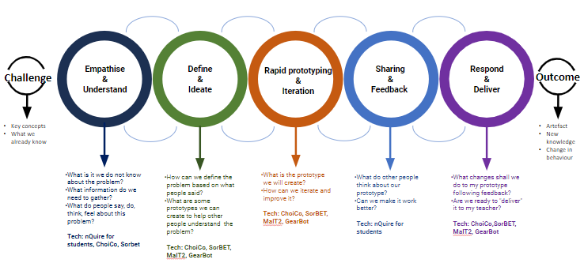

### PHASE 0: Challenge

Give a short description of the challenge the project addresses.

* *What is the problem or issue they would like to explore?*
* *What are the related key concepts?*
* *What do the students already know about it?*
* *What information do they need to gather?*

### PHASE 1: Empathize & Understand

*In the “Empathise & Understand” phase students explore (diverge) and understand the problem of their Design Thinking project for which they will develop a final artifact. This involves a) exploring various aspects of the problem and developing an understanding of the issue at hand and b) empathize with their potential audience, creating online surveys in nQuire asking questions to discover their needs. When you design the activity think about how you are going to support your students:*

* *Which are the people involved?*
* *What do they say, do, think, feel about this problem?*

Duration: *e.g., 2 hours*

* Take into account that activities like creating a questionnaire using NQuire require your students to become familiar with the tool.*

*Take some time to present the NQuire functionalities to your students (e.g. show them an existing ‘mission’.) Ask them to think of the questions they will ask first and then create their ‘mission’. To save time, each group can distribute their mission to their classmates or school teachers during a recess (e.g. using tablets).*

Description of the activities:

*e.g. In this phase students first discuss the issue with the teacher and explore the videos provided. Then they decide on questions they want to ask their audience and create an online questionnaire with NQuire. Following they share the questionnaire with their audience y sending the link of the mission via mail and collect the answers. They discuss the results with their group and discuss interesting findings that may be useful for developing a concept for the game they will develop.*

expected use of extendt2 technology:

MaLT2    ChoiCo  SorBET  VRobotics  NQuire  No technology

students’ constructions: *e.g Online questionnaire*

Students’ expected interactions:

| Between the members of the group | *e.g. discussion and argumentation on what questions need to be included in the questionnaire* |
| --- | --- |
| Between the groups | *e.g. Different groups do not interact during this phase* |